Dear 8th Grade Students and Parents,

We are entering an exciting time of the school year! In the next two weeks, 8th grade students will begin the process of registering for high school courses. For many, this is a new experience, and for those with older children, please keep in mind that the process often changes from year-to-year. Regardless, I will be here to guide you each step of the way!

I will be meeting with students through English classes to review registration information. Information and reminders will also be sent through email, Canvas, and posted through the school newsletter. Be sure to review this information as a family and in its entirety to ensure informed choices are made and important deadlines are met.

Attached you will find:
- Directions for Entering Course Requests Online
- Course Placement Review Directions
- Ninth Grade Schedule Examples
- Grade 9 Course Selection List

In addition, a timeline as well as valuable resources are included below.

I look forward to working with our 8th grade Falcons! Do not hesitate to contact me with any questions/concerns.

Trish Marton, 8th Grade School Counselor
Patricia_Marton@hcpss.org
~~~~~~~~~~~~~~~~~~~~~~~~~~~~~~~~~~~~~~~~~~~~~~~~~~
2020-2021 HIGH SCHOOL REGISTRATION TIMELINE

January 3, 6, 7 | High School Course Registration & Catalog Lesson with Mrs. Marton (English Classes)
January 8 | Students and parents can view teacher recommendations and should begin entering course requests and alternates into Synergy. Be sure to log in through the student account, not through a parent account.
January 9 | Rising 9th Grade Parent Orientation at Marriotts Ridge HS (6-8 pm)
January 17 | 1. DEADLINE for completing High School registration in Synergy  2. Deadline to submit ONLINE Course Placement Reviews (waivers) in Synergy
June 3 | Student field trip to Marriotts Ridge High School

Registration Resources
-Catalog of Approved High School Courses: https://www.hcpss.org/academics/course-catalogs/
-Course Registration Instructions: https://youtu.be/Ejo_RmcFtts
-Course Placement Review Instructions: https://youtu.be/RWt11DQvoRM

Level 3 World Languages
Course numbers for multiple level 3 World Languages are not included on the Grade 9 Course Options document. Please note the following:
Course Name | Course Number
Chinese III | WL-602-1
Chinese III Honors | WL-603-1
French III | WL-604-1
French III Honors | WL-605-1

Directions for Entering Course Requests Online

Students and parents/guardians will make course requests for electives and alternates ONLINE.

1. Access HCPSS Connect/Synergy (through your student’s login) and click on the Course Request tab.
2. Click the Click here to change course requests button.
3. Select electives to ensure that you have seven credits requested.
NOTE: You can search by department, course name, or for electives.

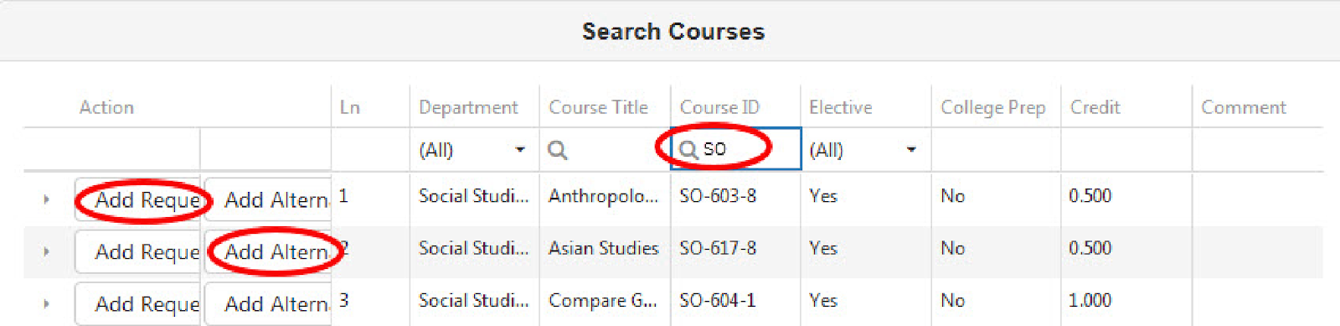

4. Click either the Add Request or Add Alternate button to select a course.
5. Select three courses to be used as alternates. Choose your alternate course wisely as it is very possible for a student to receive an alternate course on his/her schedule
6. Click the Click here to return to course request summary button to review the requests.
7. Click the Lock Course Requests button when you are ready to submit your final requests. CHANGES CANNOT BE MADE AFTER COURSES HAVE BEEN LOCKED. Any changes must go through the counselor once courses have been locked.

"Save" vs Lock
  - Requests are saved as soon as they are added.
  - Students can add requests and leave the page to return later to add or remove requests even if they have less than 7 credits
  - Students cannot LOCK their requests until they have at least 7 credits

NOTES:
Use the Catalog of Approved High School Courses (www.hcpss.org/academics/approved-courses/ ) to review course selections for the upcoming school year. Please note course descriptions and prerequisites.

If you do not have access to a computer, need assistance, or want to make changes after 01/17/2020, please contact Trish Marton, 8th grade counselor, at MVMS. patricia_marton@hcpss.org
If you have concerns about, or disagree with, any of the course recommendations, you may complete the ONLINE Course Placement Review in Synergy and submit it by 01/17/2020.

Ninth Grade Schedule Examples
Sample 9th grade schedules are included below. When completing your online high school registration, please keep in mind the following:
- Each student must have a total of 7 credits scheduled. Rising 9th graders typically choose 0-2 electives.
- Each student selects a Program Choice/Completer (you can choose more than one program completer).
  - World Language – In many cases it can be helpful to continue a world language in high school even if the high school graduation requirement has been met through the middle school world language program.
  - Advanced Technology Program – This includes Advanced Design Applications AND Advanced Technological Applications
  - Career Academy – Project Lead the Way (PLTW) is the only Career Academy students must start in 9th grade. If you plan to complete this academy, you must take the PLTW Engineering Design G/T class in 9th grade.
- Each student must list 3 alternate elective courses. Students are strongly encouraged to select classes of interest! It is very possible for a student to be scheduled in an alternate course due to high school scheduling constraints.
SAMPLE SCHEDULES:
English
Math
Science
Social Studies
PE/Health
World Language
Technology Education

English
Math
Science
Social Studies
PE/Health
Technology Education
Fine Art

English
Math
Science
Social Studies
PE/Health
World Language
PLTW Engineering Design G/T

English
Math
Science
Social Studies
PE/Health
Technology Education
English/Math Seminar/Reading

English
Math
Science
Social Studies
PE/Health
World Language
Fine Art

